Music development plan summary:
The Mallard Academy
All schools should have a music development plan from the academic year 2025/26. Schools are expected to publish a summary of their plan on their website from academic year 2025/26.
This template is designed to support schools to produce the summary. It should set out how the school will deliver high-quality music provision in curriculum music, co-curricular music and musical experiences, taking into account the key features in the national plan for music education:
- timetabled curriculum music of at least one hour each week of the school year for key stages 1 to 3
- access to lessons across a range of instruments, and voice
- a school choir or vocal ensemble
- a school ensemble, band or group
- space for rehearsals and individual practice
- a termly school performance
- opportunity to enjoy live performance at least once a year
The summary should reflect your school’s music provision for the given school year and your plans for subsequent years. It should also refer to any existing partnership with your local music hub or other music education organisations that supports the school with music provision.
Before publishing your completed summary, delete the advice in this template along with this text box.

Overview
Detail | Information
Academic year that this summary covers | 2025/26
Date this summary was published | March 2026
Date this summary will be reviewed | September 2026
Name of the school music lead | Jason Cocker
Name of school leadership team member with responsibility for music (if different)
Name of local music hub | Doncaster Music Service
Name of other music education organisation(s) (if partnership in place)

This is a summary of how our school delivers music education to all our pupils across three areas – curriculum music, co-curricular provision and musical experiences – and what changes we are planning in future years. This information is to help pupils and parents or carers understand what our school offers and who we work with to support our pupils’ music education.

Part A: Curriculum music
This is about what we teach in lesson time, how much time is spent teaching music and any music qualifications or awards that pupils can achieve.
Your school should already publish the school curriculum for music for each year group online. This should also include how you are increasing access for disabled pupils and supporting pupils with special educational needs (SEND). Include a link to this information in this summary. For more, see the school information guidance on curriculum and on SEND for maintained schools and for academies and free schools.
If not included in your published school curriculum information, set out how time per week is allocated for curriculum music for each key stage and term (or each half-term) of the academic year.
Also consider including:
- whether your school music curriculum is informed by the model music curriculum (March 2021), non-statutory guidance for teaching music from Key Stages 1 to 3 or any other published curriculum guidance.
- a brief summary of the opportunities pupils have to learn to sing or play an instrument during lesson time, such as through whole-class ensemble teaching in some or all year groups.
- information on any partnerships the school has to support curriculum music, such as with your local music hub or other music education organisations. If you are a music hub lead school, you can refer to this here.
For secondary schools: Set out what music qualifications and awards pupils can study and achieve at the school in the academic year, including graded music exams (all key stages) and GCSE, A level or vocational and technical qualifications (at key stage 4 and 16 to 18). If your school already publishes this information, include a link in this summary.

Intent
Why is Music Important?
At Mallard Primary School, our Music curriculum is inclusive, challenging and ambitious for all learners. We provide a high-quality music education that engages and inspires pupils to develop a love of music and their talent as musicians, and so increase their self-confidence, creativity and sense of achievement.
Core areas of study include singing, listening and appraising, composing and improvising and instrumental performance. These are built cumulatively throughout the curriculum to ensure that all pupils develop their engagement with, and knowledge of, music over time. This includes a focus on learning to play a range of instruments confidently. Significant musicians and musical works are studied, with the intention of exposing pupils to a wide range of music that will inspire them and connect them to the world around them. There is a strong emphasis on the language that pupils need to explore their own musicality. This is carefully and deliberately planned so that pupils revisit and embed this knowledge over time.
We aim to build a strong and rich musical culture at Mallard Primary school in which pupils can thrive.

At Mallard Primary School, children will gradually build on their music skills throughout the Key Stages based on National Curriculum expectations. Our school music curriculum is informed by the model music curriculum.

Key Stage 1
Pupils should be taught to:
- use their voices expressively and creatively by singing songs and speaking chants and rhymes
- play tuned and un-tuned instruments musically
- listen with concentration and understanding to a range of high-quality live and recorded music.
- experiment with, create, select and combine sounds using the inter-related dimensions of music.
Key Stage 2
Pupils should be taught to sing and play musically with increasing confidence and control. They should develop an understanding of musical composition, organising and manipulating ideas within musical structures and reproducing sounds from aural memory.
Pupils should be taught to:
• Play and perform in solo and ensemble contexts, using their voices and playing musical
instruments with increasing accuracy, fluency, control and expression
• Improvise and compose music for a range of purposes using the interrelated
dimensions of music
• Listen with attention to detail and recall sounds with increasing aural memory
• Use and understand staff and other musical notations
• Appreciate and understand a wide range of high-quality live and recorded music drawn
from different traditions and from great composers and musicians
• Develop an understanding of the history of music

Music long-term sequence There is a significant focus on revisiting throughout the curriculum with the aim of pupils mastering key knowledge and skills that can be built on as they move through the programme of study
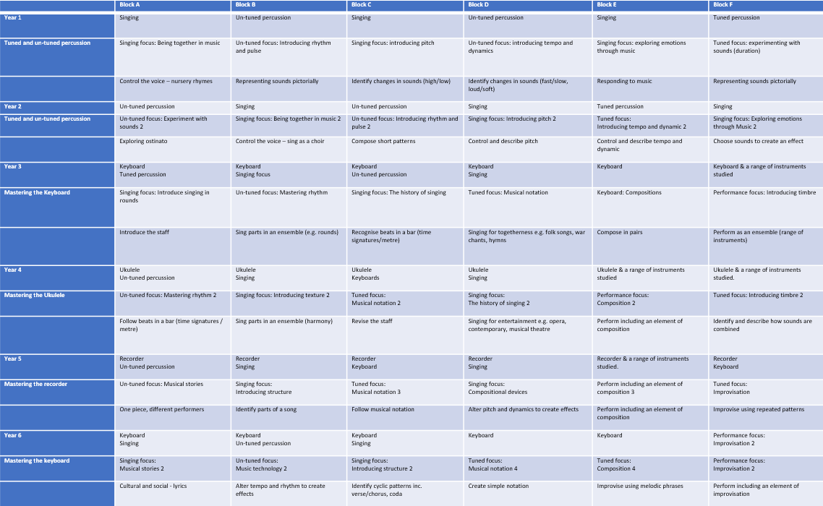

What will pupils know and be able to do at key points of the curriculum?

During KS1, CUSP Music aims to secure strong musical foundations for pupils. This includes a strong focus on learning musical vocabulary and significant opportunities to master rhythm and pulse.

As pupils move into KS2, they will begin to learn a specific instrument throughout the academic year, alongside exploring a range of other tuned and untuned instruments,
Year 4 – ukulele, Year 5 – guitar. The aim is for pupils to secure a good level of technical and creative skill in playing a musical instrument.

For each year group, blocks provide the opportunity for pupils to prepare and perform musical compositions. In KS1, this is woven into several blocks to build pupils’ confidence and experience base. Throughout KS2, pupils begin to perform in different musical ensembles, culminating in them performing their own compositions and improvisations by the end of Year 6.

Pupils will be taught to read music from the earliest stages with the expectation of this gradually developing as pupils’ experience base builds.

Music from a wide range of cultures, time periods and traditions is studied across the curriculum, with plenty of opportunities for pupils to revisit significant musicians and compositions within and across years. This is important to help pupils embed learning and make connections between what they already know and their new learning.

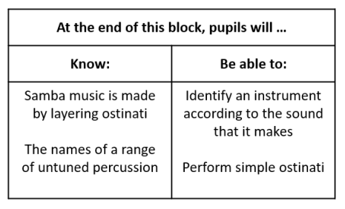

KS1: Progression of Skills: Singing

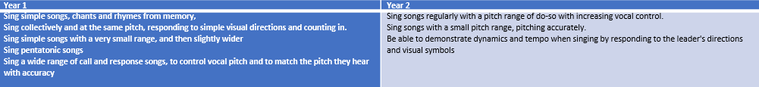

KS1: Progression of Skills: Composing

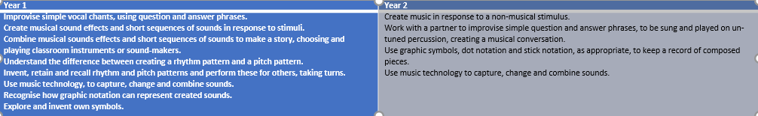

KS1: Progression of Skills: Pulse/rhythm

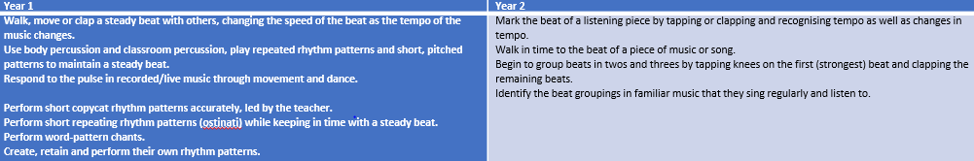

KS1: Progression of Skills: Pitch

KS2 Progression of skills: Instrumental Performance and Reading Notation

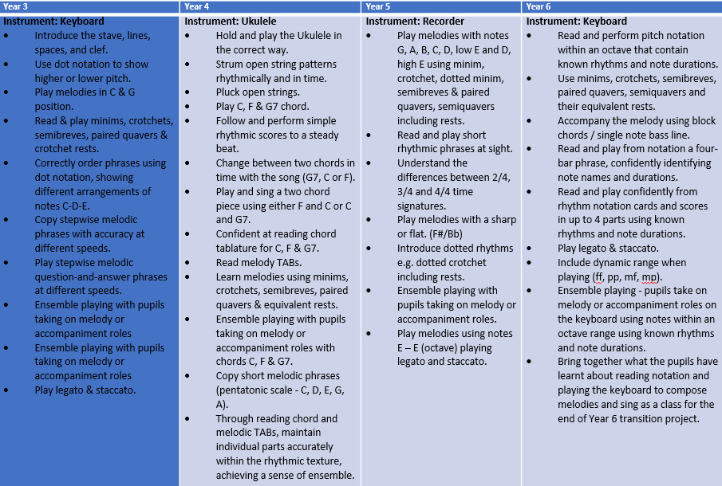

Progression of skills: Instrumental Performance and Reading Notation for each block
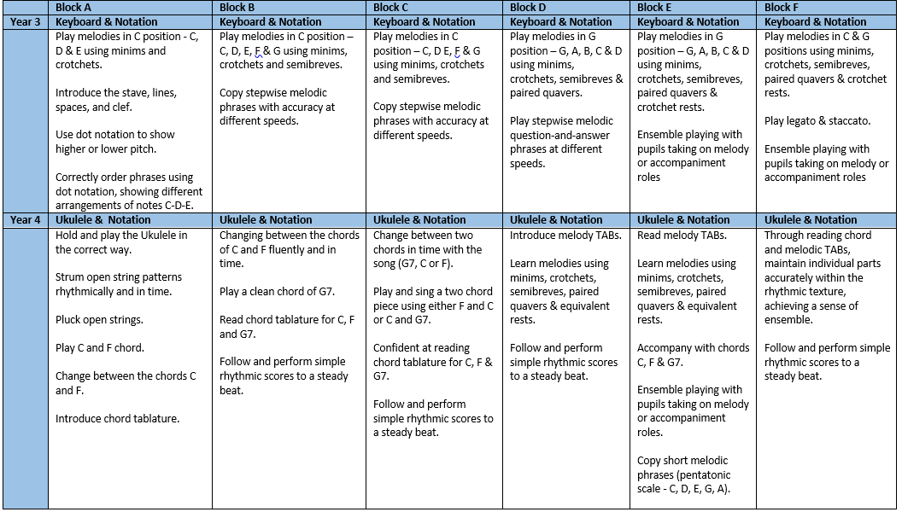
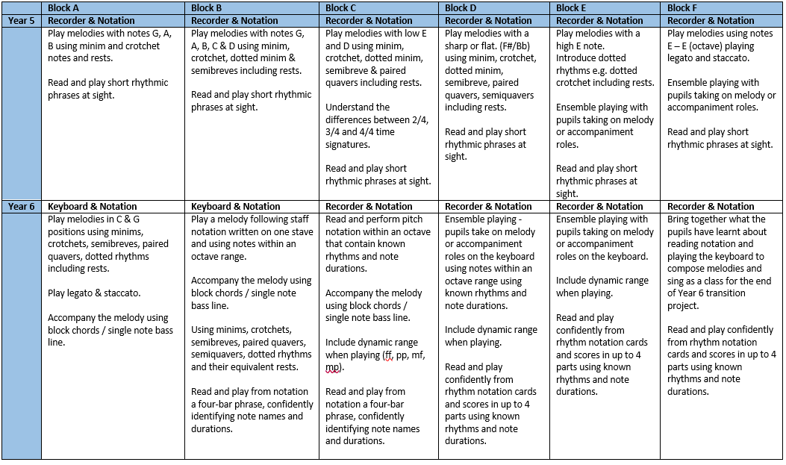

KS2 Progression of skills: Singing
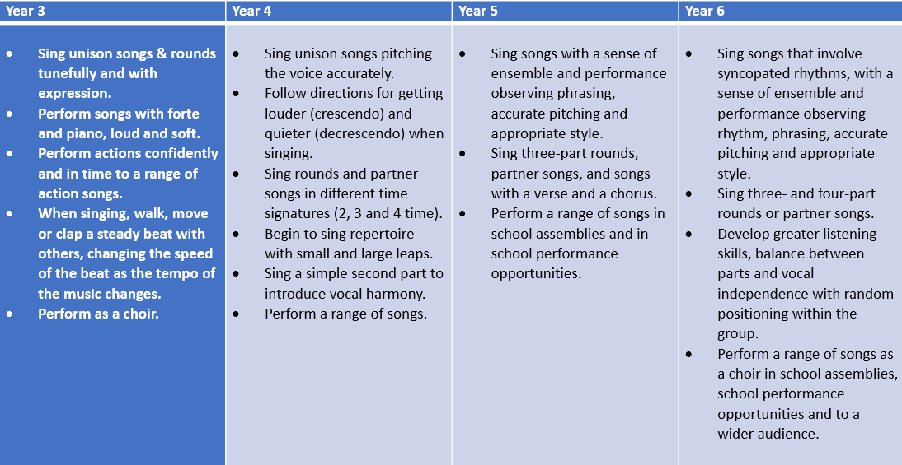
KS2 Progression of skills: Composing and Improvising
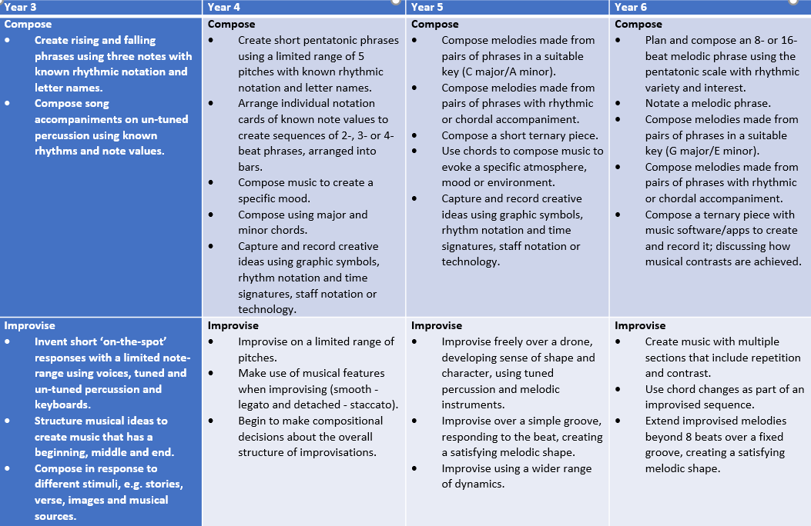

KS2 Progression of skills: Listening Across all year groups, pupils will develop their shared knowledge of important moments in the evolution of music and of key musicians, including composers and performers, in a range of genres and styles. The history of music will be explored in a variety of ways, placing music in artistic, historical, social and political contexts, and building meaningful and memorable connections.

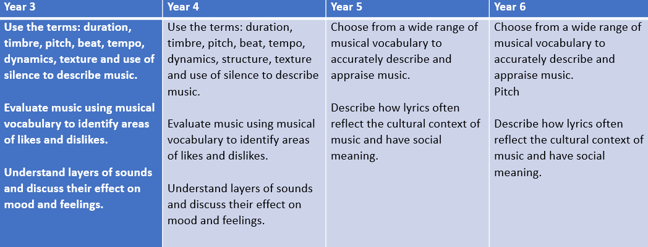

Content and sequence - EYFS to Key Stage 1

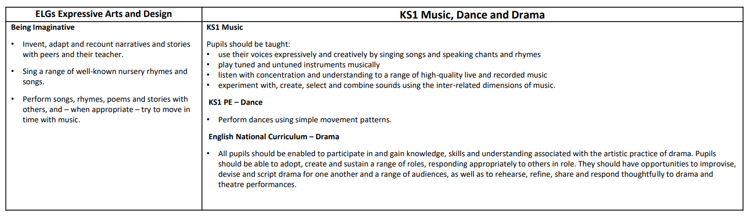

Content and Sequence: Year 1 (Learning intentions that will be assessed are included).
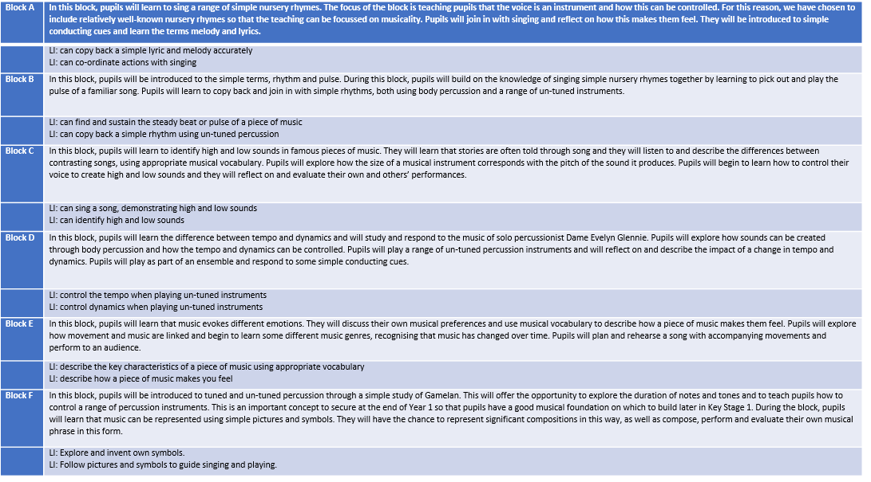
Content and Sequence: Year 2 (Learning intentions that will be assessed are included).
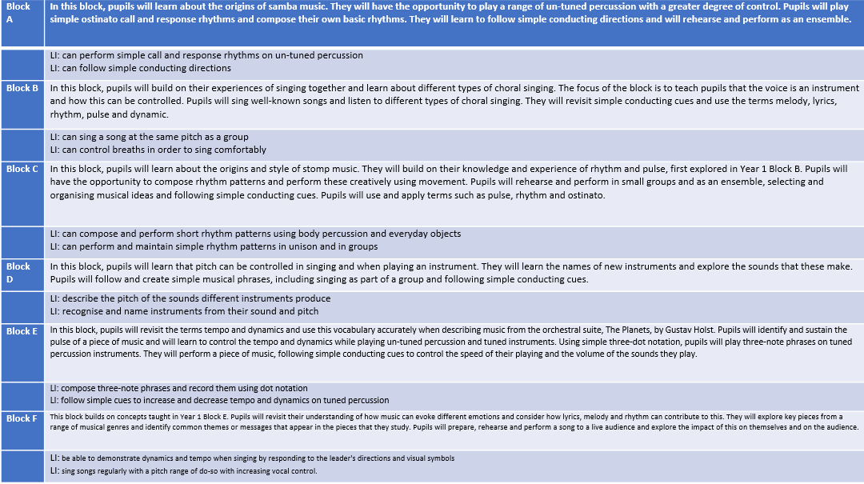

Content and Sequence: Year 3 (Learning intentions that will be assessed are included)
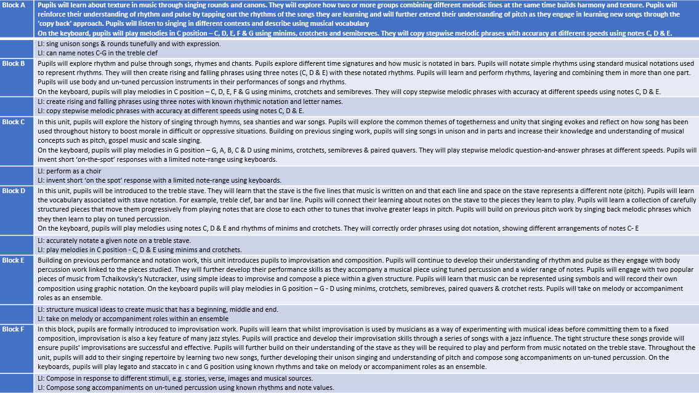

Content and Sequence: Year 4 (Learning intentions that will be assessed are included)
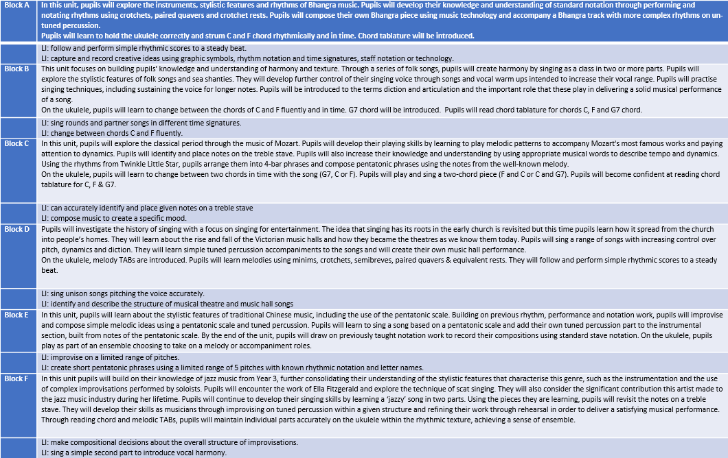
Content and Sequence: Year 5 (Learning intentions that will be assessed are included)
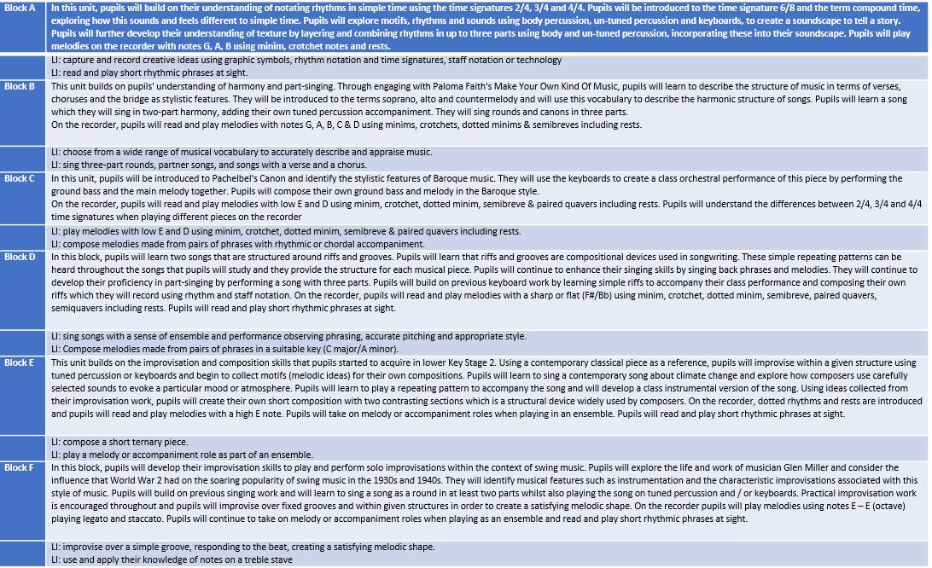
Content and Sequence: Year 6 (Learning intentions that will be assessed are included)
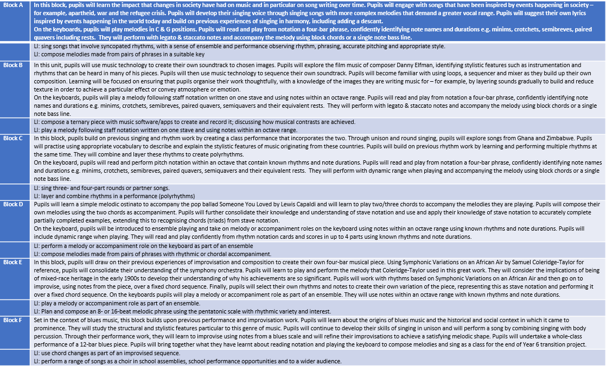

How is Music organised?

Music is taught from Years 1 – 6 weekly for approximately 60 minutes. Each year group has 6 blocks of at least 5 weeks teaching. Additional weeks in the academic year can be used for consolidation, revisiting or enrichment.

 | Tuesday | Wednesday | Thursday | Friday
AM | Year 2 | Year 3 | Year 4 | Reception
PM | Year 6 | Year 5 | Year 1 | Enrichment

Across the year, each year group will focus on developing singing, playing a range of untuned and tuned instruments and building their knowledge about music. Pupils will build their knowledge and musical skills year on year, becoming more expert in playing and appraising a wide range of musical styles.

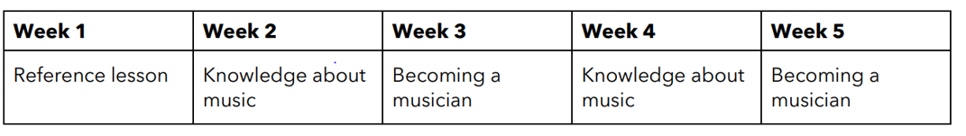
Revisiting
Revisiting is inherently built into the architecture of our Music curriculum. This can be seen in many places, such as:
• between individual blocks in each year group on the long-term sequence
• within blocks in the Revisiting part of each lesson
• in the vocabulary quizzing that can be used throughout, at the end of and after a block of study.
Pupils will have multiple experiences of music every day. As the DfE’s Model Music Curriculum says, “Music is the soundtrack to our lives.”
Every opportunity is taken to revisit key musical concepts and language wherever possible. This could be during assemblies, whenever music is evident in the classroom or in wider curriculum subjects. This includes drawing attention to the style of music, the instruments or sounds pupils can hear or rehearsing key vocabulary to describe musical sounds (e.g. pitch, volume, rhythm).

Cultural Development
Our music curriculum has a strong focus on supporting pupils to meaningfully develop their understanding of other cultures and issues that impact on the wider global community. There is a specific emphasis on teaching pupils about music that originates from a wide range of cultures, traditions and time periods, including those that are both similar and different to pupils’ own experience of music in modern Britain.
Significant musicians and compositions are included throughout the curriculum. Pupils will learn about important works of music from around the world and their contextual significance in history and society. These have been carefully mapped across the curriculum to ensure a balance of new studies and opportunities to revisit those that pupils have already met. This supports pupils in making connections between musicians and musical works and embedding their aural repertoire cumulatively.
It is important to link this learning to pupils’ learning from the wider curriculum, for example, their study of significant historical events, different faiths or the geography of the world.

Knowledge Notes
Knowledge Notes are used to support instruction and the revisiting of new concepts. This strong focus on cognitive science provides the framework for pupils to deepen and broaden their knowledge of music and become confident, inspired musicians.
The Knowledge Note should be introduced at the start of Lesson 1 so that pupils know what core knowledge and skills they will acquire and the technical vocabulary they will learn as the lessons progress.

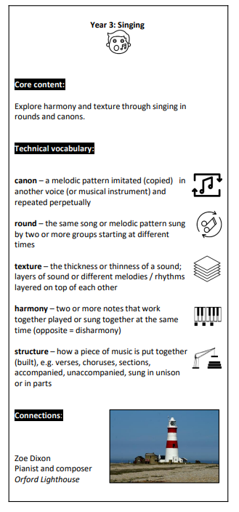

Knowledge Notes
Core content Pupils are provided with a brief summary of the content of each block.

Technical vocabulary
Key technical vocabulary that is covered in each block is listed, providing a useful glossary of terms for pupils to refer to. Icons have been used to aid understanding of terms.
Connections Images showing examples of significant musicians, works of music or performances are used so that pupils can refer to these as a reminder of the music they have studied.

Tailoring for SEND

Specific activities or pedagogy may need to be adjusted to ensure that pupils with SEND are able to access the materials and participate fully in the lesson.

Pupils with language and communication difficulties (including those with ASD) may need additional visual prompts to help them understand what is expected of them.
Some pupils may require individual task boards to enable them to follow a series of steps where a task has been broken down into smaller, more manageable chunks.

Some pupils may have a hearing impairment. Teachers should think carefully about how this impacts their ability to hear and produce sounds and consider how best to adapt the Music lessons to ensure these pupils can be successful.

Some pupils may have a visual impairment. This may impact their ability to read and follow musical notation. Teachers should think carefully about how they can adapt these lessons, possibly including the use of technology, to ensure that these pupils can access the same high-quality curriculum experience.

For some pupils who have specific challenges around processing, some of the lessons may require adaptation to ensure that all pupils can participate fully in the lesson. This may mean reducing the number of instructions or steps in a task, introducing the use of a reader for lessons with a reading element (including lyrics), or any other adaptations specific to the pupils in your class.

Partnerships the school has to support curriculum music.
We work closely with the following music education organisations:
- CUSP
CUSP is an evidence-led curriculum that is built on the principles underpinned by the best cognitive and neuroscientific research available. The curriculum is underpinned by explicit vocabulary instruction and research-focused pedagogy.
- All Aboard Music Network
The All Aboard Music Network is a friendly, relaxed space for musicians, music leaders and educators to come together to share, learn and develop their skills in music-making with Disabled children and young people.
- Doncaster Music Hub
Doncaster Music Education Hub is a collection of partners working together to provide every child in Doncaster the opportunity to sing and learn a musical instrument, and to perform as an ensemble regardless of race or gender. Doncaster Music Education Hub provides support with training, music strategies, resources or teaching.

2025/6 MUSIC CPD Mallard Academy has accessed
- CUSP Subject Leadership session with Alex Bedford and Danny Howden 5.10.23
- All Aboard Music Network – Making Music with Deaf pupils 8.11.23
- Doncaster Music Education Hub - African Drumming Workshop with Alistair Skobie at the Lightbox, Barnsley 11.12.23
- Doncaster Music Education Hub - Create and Sing: The Magic Flute by the Royal Opera House 23.11.23
- Doncaster Music Education Hub - Composition for Model Music Curriculum 29.1.24
- All Aboard Music Network: Social, Emotional and Mental Health in the music classroom 27.2.24
- Doncaster Music Education Hub - Introduction to Fundraising 11.3.24
- Doncaster Music Education Hub - Sing the World 20.3.24
- Doncaster Music Education Hub - Sing Out CPD 17.4.24

Part B: Co-curricular music
This is about opportunities for pupils to sing and play music, outside of lesson time, including choirs, ensembles and bands, and how pupils can make progress in music beyond the core curriculum.
Start with what music tuition your school offers outside of what is taught in lesson time, including one-to-one, small-group and large-group tuition for instruments or voice.
Set out what ensembles that pupils can join outside of what is taught in lesson time, such as choirs or vocal ensembles, as well as instrumental ensembles, bands and groups, and other forms of music-making.
Set out how pupils can make progress in music outside of lesson time, including instrument loans, weekend, after-school or holiday provision such as Saturday music centres, and any qualifications or awards pupils can achieve.
Also consider including:
- what instruments are offered, charging and remissions information, and if the tuition is subsidised or free, including for parents or carers in particular circumstances (e.g. pupil premium eligibility).
- how pupils can join choirs or ensembles and from which year groups, charging and remissions information, and if the tuition is subsidised or free, including for parents or carers in particular circumstances (e.g. pupil premium eligibility).
- information on where pupils can rehearse or practice individually or in groups.
Draw on information of any partnerships the school has to support co-curricular music, such as with your local music hub or other music education organisations.
Alternative titles for Part B could be ‘Extra-curricular music’ or ‘Music tuition, choirs and ensembles’.

Extra-Curricular Music
Small group tuition
Rocksteady
- Rock and pop music band lessons. £44/month.
Let’s Make Music Programme (Doncaster Music Service) for all year groups.
- Trumpet
- Violin
- Guitar
- Flute lessons
£12/month.
In September 2026, 36 children will be having lessons that include a number of pupil premium places. Tuition is subsidised by the William Appleby Memorial Trust and instrumental hire is free.
Specialist Music Teacher employed by the school
- Clarinet (Year 5)
- Flute (Year 5)
- Rock and pop music band lessons (Year 6)
- Create and Sing Opera ensemble (Year 3-4)
- Instrumental ensembles for the gifted and talented within the school. (Year 3-6)
- KS2 Bamboo tamboo ensemble
Tuition and instrumental hire are free and is accessible to all.
Choirs and ensembles
- KS1 choir
- KS1 Hand Bells ensemble
- Breakfast Club Choir (Year 3-6)
- KS2 After-school Christmas Choir Club
- KS2 After-school Sing Out Choir
- Lunchtime Year 5/6 Choir
- KS2 Performing Arts After-School Club (Year 5-6)
All clubs and ensembles are free and are accessible to all.
Pupils can rehearse or practice individually or in groups in the Red Dragon (the school’s music classroom), small hall and main hall.

Progression in music outside of school time
Instrumental lessons - instruments are on loan for children to take home and practice individually.
Pupils can make progress in music outside of lesson time
- Swaglets at The Point - singing group for 9–12-year-olds performing chart hits with choreography. Tuesday evenings during term time, 4.30pm – 5.15pm
- First verse at The Point (intro to song writing) – weekly music workshops for young people aged 10-16
- William Appleby Music Centre
Junior band (Saturday 9.15-10.15am) at Bentley My Place
Intermediate band (Saturday 10.30-11.45am) at Bentley My Place
Beginner Strings (Thursday 17:00-17:45) at The Point
Junior Strings (Monday 17.30-18.15)
Intermediate Strings (Monday 16:30-17:15) at The Point
Advanced Strings (Friday 16:30-17:15) at Bentley My Place
Beginner Guitar Group (Wednesday 16:45-17:30) at The Point
Guitar Group A (Tuesday 17:15-18:00) at The Point
Guitar Group B (Tuesday 18:15-19:00) at The Point
Beginner Brass Group (Thursday 16:20-17:05) at Town Field Primary School
Beginner & Junior Recorder Group (Thursday 16:00-16:45) at The Point
Intermediate Recorder Group (Thursday 16:45-17:30) at The Point
Theory ABRSM – 30-minute classes virtually online. £20 per term per student
- Doncaster Youth Jazz Foundation Band – Tuesdays 6.30-7.30pm at XP School
- Amped Up Music Academy – one to one lessons in instruments such as guitar, drums, piano, bass, keyboards and vocals.
- Rainbows Connection Junior Choir – for 5–12-year-olds performing challenging, fun repertoire. Thursday evenings, 6-7pm at Hill House School.
- Sharon Richards Singing School – singers from age 7-70 that perform at all kinds of events from ‘flashmob’ surprises to general performances.
​

Part C: Musical experiences
This is about all the other musical events and opportunities that we organise, such as singing in assembly, concerts and shows, and trips to professional concerts.
Set out what musical experiences are planned for the academic year, including regular events such as singing in assembly, musical performances, concerts and shows at the school, and trips to concerts outside of the school.
For musical performances, concerts and shows in and out of schools, include how pupils get involved and from which year groups, whether pupils are participating or are members of the audience.
Also consider including:
- charging information, and if events are subsidised or free, including for parents or carers in particular circumstances (e.g. pupil premium eligibility).
Draw on information of any partnerships the school has to support musical experiences, such as with your local music hub, music education organisations, music organisations or musicians.
Alternative titles for Part C could be ‘Musical events’ or ‘Musical performances’.

Musical Experiences
School singing We have a whole school weekly singing assembly on Tuesdays that lasts for 20 minutes. We always start with vocal warm-ups before we start to sing.
TERM 1 Warm-ups Boom chika boom Do you dooty Oleo Shake my sillies out A Little Echo
Songs Califlower fluffy Seeds of Friendship In Flanders Field In the Autumn Jack O’lantern Together as One Firework Make a Noise Away in a Manger It was on a Starry Night Sing for Peace The Twelve Days of Christmas Shepherd’s Song Jingle Bells We Wish you a Merry Christmas Santa Claus is Coming to Town Rudoph the Red Nose Reindeer
TERM 2 Warm-ups Rubber Chicken Grandma Rap Queen – call and response from Live Aid Bootie Bootie Clappety

Songs Be Safe! Don’t Stop Good to be Me I’m a Believer The Internet Rules Three Little Birds Walking on Sunshine British Values Song Come Dance with Me Up Up Up! All About You
TERM 3 Warm-ups My Hat it has Three Corners My Voice is really Funky I Love the Flowers On Top of Spaghetti
Songs Build it High Don’t Worry be Happy I Belong You are my Sunshine Let’s go Fly a Kite I Wanna Rock
Weekly school singing has strong links with important events throughout the year such as Harvest, Remembrance Day, Christmas, Easter, Odd Socks Day, Internet Week, Children in Need, Mental Health Week and Sing Up Day 2024.

Musical performances and events that pupils have participated in
TERM 1
Breakfast Club Choir (KS2) During Term 1, children in Breakfast Club on a Friday morning, prepared songs to perform at St John’s Hospice Christmas Coffee Morning.
Christmas Choir (KS2) An after-school club that prepared songs to perform at Cedars Care Home, Tesco, Balby and the Christmas Concert. They also lead Carols Around the Christmas Tree event.
KS1 Nativity (KS1) KS1 performed their nativity to the whole school and to parents/carers.
Carols Around the Christmas Tree (All year groups) During school singing, we learnt songs that were sung at an after-school event where all pupils and parents could come to the hall wearing their Christmas jumpers and drink hot chocolate, eat mince pies and sing Christmas carols together around the Christmas tree.
Christmas Church service at the White Church in Balby. (KS2) The Reverend Canon Ian Smith lead a KS2 Church service at the White Church. We had the opportunity to sing Christmas songs we had prepared in school singing.
Christmas Concert (KS2) Christmas Choir, flutes, clarinets and rock bands performed to parents/carers at our annual Christmas concert.
Choir performance at Tesco (KS2) The Christmas Choir raised £250 towards the cost of a coach to take us to Sing Out 2024 massed choir concert.
CUSP Music Christmas Festival (All year groups) Each year group prepared a performance that included singing, playing musical instruments and composing to a winter theme. Each year group’s performance was recorded and shared for all classes to watch.
TERM 2
KS1 Mini-Music Concert Parents and carers were invited to watch all KS1 pupils taking part in our KS1 Mini-Music Concert. Year 1 sang songs with actions, Year 2 played the bamboo tamboos, KS1 Lunchtime Singing Club sung a variety of pieces and Year 1 performed on handbells.

TERM 3
Year 5/6 Choir Due to our close links with St John’s Hospice, we performed at their Summer Coffee Charity morning. We performed twice – once to the public and once to the patients inside the chapel.
Sing Out (KS2) 35 children performed at Sing Out, a massed-choir event to an audience of 1000. Parents and carers attended the event. They prepared for the event at an after-school Sing Out club. This event was organised by our local music hub.
Recital Concert The concert is an opportunity for children in all year groups to perform to parents and carers and show off their musical talent through singing, acting, dancing and playing musical instruments. The following ensembles will take part: Sing Out Choir, Year 1 singing group, Year 2 bamboo tamboos, Year 3 keyboards, Year 4 ukuleles, Year 5 recorders, Year 6 keyboards, Year 5/6 Choir, Sing Out Choir, Performing Arts Group, Create and Sing Opera Group, clarinet ensemble, flute ensemble, rock bands and KS2 bamboo tamboos.
Year 6 Leavers Assembly Year 6 rock bands will accompany the songs at this event whilst all of Year 6 sing to their parents/carers.
Magic Flute Create & Sing Share & Celebrate (Royal Opera House) Year 3 & 4 students who have been part of the Create and Sing group join ROH artists, and schools around the country, for a live streamed event to share and celebrate their learning.
Rocksteady Concerts Throughout the year, Rocksteady have had termly concerts for parents/carers to attend.

All musical concerts, shows and events throughout the year will be free to all parents and carers.

In the future
This is about what the school is planning for subsequent years.
Use this space to include any information on any improvements you plan to make for subsequent years in curriculum music, co-curricular music or musical experiences, including when you plan to introduce changes.
Also consider including:
- any information that relates to the 7 features of high-quality music provision (see the text box at the beginning of the template), such as increasing lesson time to one hour a week each term, introducing the teaching of new instruments or having a termly school performance.

- Let’s Make Music Programme (Doncaster Music Service) for all year groups.
- Trumpet
- Violin
- Guitar
- Flute lessons
£12/month.
In September 2026, 36 children will be having lessons that include a number of pupil premium places. Tuition is subsidised by the William Appleby Memorial Trust and instrumental hire is free.
- A school orchestra to be established with close links with the Let’s Make Music Programme. To start in term 2 once students have become more established on their musical instruments.
- Musician of the Month. Every month a new musician is introduced in assemblies and is heard on the speakers around the school during transition periods.Purpose to expose children to a range of composers and performers. Term 1 to be established.
- Change the Year 6 instrumental programme to electric/bass guitars instead of keyboards. 2025-2026 academic year.
- Opportunity to enjoy a live performance by professional musicians within the school setting or at a theatre or concert hall (musical, opera, classical orchestra etc). 2025-2026 academic year.
- African Drumming Club 2025-2026 academic year.

